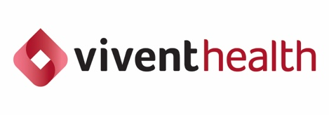

FOR IMMEDIATE RELEASE

VIVENT HEALTH WELCOMES NEW BOARD MEMBERS TO ADVANCE MISSION OF ACHIEVING HEATH JUSTICE FOR PEOPLE LIVING WITH HIV

Milwaukee, WI — [1/31/25] – Vivent Health, a leading provider of HIV care and prevention, is pleased to announce the appointment of five new members to its national Board of Directors. These individuals bring a wealth of expertise, diverse perspectives, and a shared passion for advancing heath equity and justice for individuals living with and impacted by HIV, further strengthening the organization’s commitment to delivering high quality health outcomes to all individuals we serve.

The new board members include:

Irene Jakimcius, JD, (Chicago, IL) Now retired, Irene worked as a healthcare attorney for 25 years, focusing her practice on FDA, DEA, Medicare/Medicaid fraud and abuse compliance, and state pharmacy law. As a healthcare lawyer for a large drug and medical device manufacturer Irene became interested in how the healthcare system treated people living with chronic diseases. It was through her work with businesses making products for end stage renal disease, hemophilia and other chronic conditions that she learned the focus should always be on treating the patient as a whole, not just the disease to optimize outcomes. Irene is honored to be working with an organization with the same public health focus.

Saboria Thomas, MD, MPH (Detroit, Michigan) is a second-year family medicine resident at Wayne State School of Medicine, working to specialize in HIV/AIDS. Additionally, she’s participating in the MIDOCs (Michigan Doctors Improving Access to Care) state-funded program, for physicians that are dedicated to primary care in underserved areas in the state of Michigan. Dr. Thomas received her Bachelor of Arts in Psychology and Master’s in Public Health degrees from the University of South Florida (USF), and her Doctorate of Medicine degree from Ross University School of Medicine.


John Magnelia (Chicago, IL) is the Business Development Lead for the Public Sector at Kong, Inc., a software company specializing in cloud-native technologies that help organizations connect and manage their Application Programming Interfaces, which are fundamental to modern software. He brings extensive experience advising public, private, nonprofit, and government organizations on best practices for innovating operations through technology. John brings a new perspective to the board and is recognized as one of the many relentless champions and change agents who are part of the next generation of leaders.

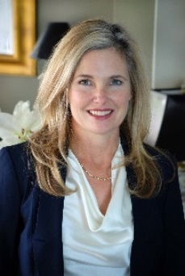
Cristina McGarr, JD (Boulder, CO) is a founding partner in her law firm with offices in Colorado and Texas and head of the firm HR committee. As a 30 plus year employment law attorney, Ms. McGarr regularly counsels employers on all employment related matters. She has been practicing in Colorado for the last 15 years and served as chair of the HR committee of the Board of Boulder Valley Health Center for 6 years. She continues to volunteer on the Boulder County Campaign for the Legal Aid Foundation of Colorado and other local non-profits. She is the mother of three and is a graduate of Wake Forest University and the University of Georgia School of Law.

Ryan Beck, MPH (Austin, TX) is a Senior Consultant serving within the Strategy and Analytics practice at Deloitte Consulting LLP. He holds a Master’s in Public Health and over nine years of experience in grants management, data reporting, stakeholder and partner engagement, disaster response, program strategy and management, and policy analysis. His strategic planning, project management, and process improvement skills have helped a variety of federal and state clients find innovative solutions to a range of organizational, budgetary, and programmatic concerns.

In addition, 2025 marks a change in the officers of the Board of Directors. Noel Landuyt, PhD of Austin, Texas has assumed the role of Board Chair. Michael Murphy of Chicago, IL was elected Vice Chair.

“We are excited to have these outstanding individuals join Vivent Health's national Board of Directors. Each new member brings distinct perspectives and a steadfast dedication to improving health equity for people living with or impacted by HIV,” says Noel Landuyt, PhD, Vivent Health Board Chair. “Our priority has been to ensure the Board is attuned to the needs of the communities we serve. These new members bring invaluable expertise and a fresh outlook that will strengthen our efforts and drive meaningful progress.”

About Vivent Health

Rooted in our legacy organizations’ commitments to serve those impacted by HIV, Vivent Health strives to achieve health justice for people living with HIV by providing lifesaving healthcare and critical social services tailored to each person we serve. We have advanced equitable health outcomes by supporting our local communities through awareness, education, fundraising, prevention, and advocating for policies that ensure everyone impacted by HIV can live their healthiest life.

Vivent Health currently serves nearly 17,000 people living with and vulnerable to HIV and sexually transmitted infections, as well as countless people at risk for opioid overdose. Vivent Health currently has clinics Denver, CO; Chicago, IL; Detroit and Ypsilanti MI; Kansas City and St. Louis, MO; Austin, TX; and 10 cities throughout Wisconsin including Milwaukee. Learn more at ViventHealth.org.

